Flushing Primary School – GEOGRAPHY CURRICULUM MAP |  |  |  | 
Geographical Concepts | Locational Knowledge Place Knowledge Human & Physical Geography Geographical Skills & Fieldwork
 | AUTUMN | SPRING | SUMMER
EYFS | Exploring Maps | Outdoor Adventures | Around the World
Y1/2 YEAR A | What is it like here?  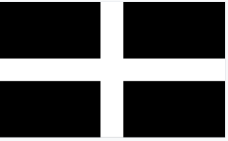  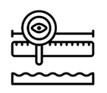 | What is the weather like in the UK?  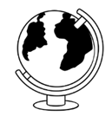 | What can you see at the coast?  
Y 1/2  YEA | Where am I? | Would you prefer to live in a hot or cold place? | What is it like to live in Shanghai?
Y3/4  YEAR A | What are rivers and how are they used?   | Who lives in Antarctica? | Where does our food come from?
Y 3/4  YEAR B | Are all settlements the same? | Why are rainforests important to us? | Why do people live near volcanoes?
Y5/6  YEAR A | Why do populations change? | Would you like to live in the desert? | Can I carry out a fieldwork enquiry?
Y5/6  YEAR B | What is life like in the Alps? | Why do oceans matter? | Where does our energy come from?

