 | Learning Overview |  |  |  |  |  |  | Term – Summer 2026 |  |  | Class - Seals
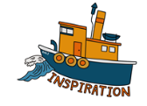 |  | Worship at the Beach and Bowling Green  World Earth Day  Mental Health Awareness  Library launch day  Class trip to Trevaskis |  |  | 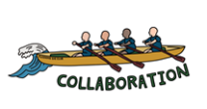  Working | Workshop at the church  Visit to the Food Barn  School Sports Day  Football World Cup Art Day  Colour run  Transition |  |  | 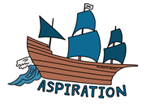 |  |  | Visit from an illustrator  Still life art workshop  Food tech knowledge and skills  Water confidence and strokes
In Science we are learning about: |  |  |  | In Computing we are learning about: |  |  | In Geography we are learning about: |  |  | In History we are learning about:
The human digestive system and food chains. Light, reflection, shadow and safety. |  |  |  | Using technology safely. Presenting leaning using digital programmes and Power Point. |  |  | Where our food comes from.  Class trip to local farms. |  |  | The changes in Britian after the Anglo-Saxon invasion.
In Art we are learning about: |  |  |  |  | In Music we are learning about: |  |  |  | In Design Technology we are learning about:
Developing drawing skills.  Take part in a still life workshop and a world cup art project. |  |  |  |  | Sing songs with increasing confidence  and control during worship. |  |  |  | A healthy and balanced diet.  Seasonal foods and how they are grown.  Visits from people who grow/cook food.
In Religious Education we are learning about: |  |  | In Personal, Social & Health Education we are learning about: |  |  |  |  | In PE we are learning about: |  |  | In French we are learning about:
How and why do people mark significant events.  How worship and festivals matter to Muslims. |  |  | Relationships and changes. |  |  |  |  | Weekly athletics lesson at the Bowling Green and swimming session at Helston Leisure Centre. |  |  | Recap basic French vocabulary. Talk about your family and homes.

