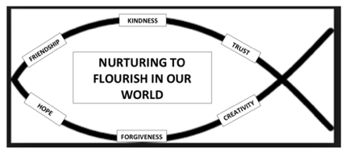
Dear Parents/Carers,
During any absence for individual/class/bubble isolation periods, Flushing School will be using a variety of methods to support parents and carers with distance learning.
One method we may use will be online teaching sessions. Your child’s teacher may ask them to connect to a ‘lesson/tutorial’ which will be taught via video link. This will give the pupils an opportunity to see the resources being used, ask questions and carry out tasks afterwards.
Initially we will be using Zoom (at a later date an installed government digital platform). A link to these sessions will be sent to the parent/carers Class Dojo account. All parents signed up to Class Dojo will get the link and it is your choice as to whether to use it, but our minimum expectation will be that all pupils will access and complete work set on the Home Learning Plan posted on Class Dojo (as we are legally required to provide it).
During the lesson, it may be possible for the pupils to see each other (however, this is in a closed area where no-one but those children in that class and the staff involved can see them), we would therefore advise that you supervise your child’s use of the system in line with our school e-safety policy. The school’s behaviour policy will be applied during online lessons and teachers will remind pupils of the code of conduct at the start of each online session.
We would like you to give permission for your child to access these resources and ask that you tick the box to give informed consent. This information will be collated in school and we will store the data in line with our normal data protection procedures.
Kind regards
Mark French (Head)
Online Lesson/Tutorial Permission Slip
Pupil’s Name(s) |  | Class(es)

I give consent for my son/daughter to take part in online teaching/tutorial sessions which will be provided by the school in the event of a class/bubble/school needing to self -isolate or in the event of local/national lockdown.

I do not give consent for my son/daughter to take part in online teaching/tutorial sessions which will be provided by the school in the event of a class/bubble/school needing to self -isolate or in the event of local/national lockdown (if you change your mind you can still access the link via Class Dojo Messages and therefore give consent).
Signed |  | Date

