

Flushing Church of England School
Our Special Educational Needs & Disabilities (SEND) Information Report 2024-2025

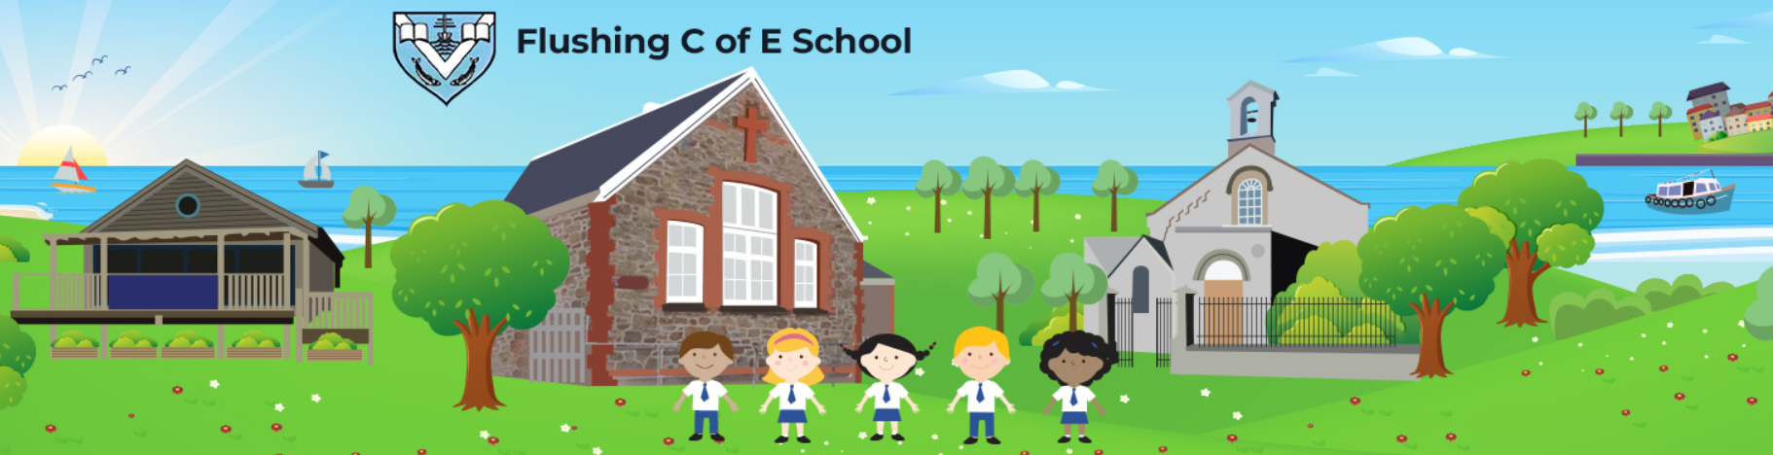

Names of our Special Educational Needs and Disabilities Coordinator: Mrs Jo Williams (SENDCO)
Contact details: senco@flushing.cornwall.sch.uk or 01326 374498 (School Office)

Name of our SEN governor: Mrs Leslie Hygate

Our School Vision & Values:

NURTURING TO FLOURISH IN OUR WORLD with our values; Friendship, Kindness, Trust, Hope, Forgiveness and Creativity.

These Christian Values form the framework on which we build our whole school community: embedded in our actions, our planning and our policies. They shape our aims, our character, our ethos and our experience of teaching and learning.

Our mission statement:

- Flushing Church of England Primary School is a welcoming, safe and caring environment within the heart of the community.

- We work together in a spirit of equality, trust and friendship.

- In our small school there is time for the individual.

- Our core Christian Values; Kindness, Trust, Creativity, Friendship, Hope and Forgiveness, aim to help guide pupils through their school-life and beyond.

- Our curriculum drivers- Inspiration, Aspiration, Collaboration underpin a broad and balanced education, nurturing our children’s skills to prepare them for the future.

- Our school philosophy aspires to achievements being celebrated and valued in the belief that every child matters to God whatever their faith or creed and it is our lifelong duty to make sure that Every Child Flourishes.
Link to our school’s Equality Objectives:

1. To use the services of the LA Equality and Diversity team to carry out whole staff/governor training in Race Equality.
2. To review the school curriculum in 2019/20, finding opportunities to include promotion of race equality and diversity.
3. Improve access to the premises.
4. Ensure school literature and polices reflect our vison & values (including equality values within this document).

Link to our school’s Accessibility Plan/Policy:
https://flushingschool.eschools.co.uk/storage/secure_download/NWJwbjdVczdGczZPVEtwTWE3YzJFZz09

Link to our school’s SEN Policy:
https://flushingschool.eschools.co.uk/storage/secure_download/ZTN4bCs5bFgvOXpMdTAvU1dwakVVZz09

Welcome to Flushing C of E Primary School – ‘Inspiration, Aspiration, Collaboration’

Flushing School is a small primary school in Cornwall. We strive to create an inclusive school environment, where all our pupils are encouraged to reach their full potential. We aim to nurture independent, lifelong learners who care and know about the best ways to look after their world and who are creative, confident and happy.

This SEND Information Report details the provision that we offer within our school and the services that we access in order to do our very best to meet the needs of all children within the school, including those with additional needs and disabilities.

Some children find certain aspects of their learning difficult to access. Our Special Educational Needs Policy is designed to support these children enabling them to overcome these hurdles and achieve the highest standards (please see the SEN policy link above, on page 2).

We welcome all children to our school and will make every effort to adapt teaching and learning to support a child’s educational development. We have a skilled and dedicated staff who treat everyone as an individual and celebrate all achievements. All classes are fully inclusive.

Support for children is determined by individual need and circumstances. We have high expectations for all our children and we aim to fully extend their academic and social development. Throughout their time at our school, children may receive varying levels of support according to their changing needs and circumstances. The information below is a guide to the ‘typical’ levels of provision. The levels of support and provision will vary across time for individual children in response to their individual needs. Staff are given relevant and appropriate training, according to their needs, the needs of the children and the needs of the school.

As a school, we have a clear approach to identifying and responding to SEND. We work in partnership with the child and their parents/carers to establish the support the child’s needs. It is particularly important in the early years that there is no delay in making any necessary special educational provision.

For early identification of need and SEND we use the graduated response approach in the flow chart below:

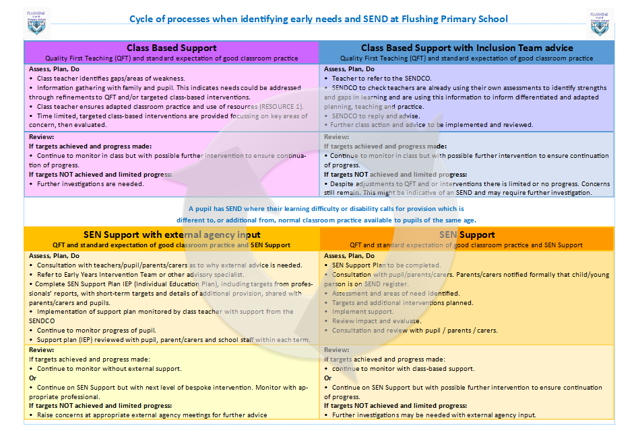
Quality first teaching (QFT)
QFT meets the needs of all learners including those with SEND and other external factors such as parents in the armed forces, pupil premium, disabilities and being in care.
All pupil progress is monitored through tracking and pupil progress meetings. Any pupils who are falling significantly outside of the range of expected academic achievement will be monitored.
If a pupil has been identified as needing extra support they will be closely monitored by staff in order to gauge their level of learning and possible difficulties. The child’s class teacher will take steps to provide differentiated/adapted learning opportunities that will aid their academic progression and enable the teacher to better understand the provision and teaching style that needs to be applied.
Children who require extra support may receive intervention on an individual or group basis with a teaching assistant.
The SENDCO will be consulted, as needed, for support and advice and may wish to observe the pupil in class.
Any concerns will be discussed with parents informally or during parent’s evenings. Parent’s evenings are used to monitor and assess the progress being made by the child.
If, despite this early intervention, the child does not make progress then, in discussion with the child, family, teacher and SENCO, they will be placed at the SEN Support level on the SEN Register.

SEN Support level

If early identification, using the cycle process above, indicates that there is still an ongoing need despite early intervention, then a child will be added to the SEN Register at the SEN Support level. SEN Support builds on high, quality first, teaching which has been adapted and personalised for individual children and is firmly based in our school’s approach to monitoring the progress and development of all children.

The SEN & Disability Code of Practice states: Where a pupil is identified as having SEND, schools should take action to remove barriers to learning and put effective special educational provision in place. This SEN Support should take the form of a four-part cycle through which earlier decisions and actions are revisited, refined and revised with a growing understanding of the pupil’s needs and of what supports the pupil in making good progress and securing good outcomes. This is known as the graduated approach. It draws on more detailed approaches, more frequent review and more specialist expertise in successive cycles in order to match interventions to the SEND of children and young people. If needed, specialist expertise may come from professionals such as; Hearing or Visually Impaired teachers, ASD advisory teachers and TA’s, SALSA and communications team, Educational Psychologists, Speech and Language Therapists, Social, Emotional and Mental Health advisers.

Therefore, SEN Support at Flushing School, is designed to provide a graduated approach based on a cycle of action that can be revisited with increasing detail, increasing frequency and with the increased involvement of parents/carers and the child. Throughout the graduated approach, the teacher remains responsible for working with the child on a daily basis and implements agreed interventions. The SENDCO supports the teacher and co-ordinates the graduated approach across the setting.

We adopt a graduated approach with four stages of action: assess, plan, do and review. This cycle of action:
• Is usually led by the class teacher, with input from the SENCO as deemed required
• Action is informed by the child’s views throughout
• Parents/carers are engaged throughout the whole process
• The cycle can be revisited, with increasing frequency in required, in order to identify the best way of securing good progress
Throughout the cycle, children’s views can be represented by parents/carers and practitioners, but in order to ensure the child’s views inform the process directly, these need to be captured before any discussion. They also inform discussions and decisions at each and every stage.

Assess, plan, do, review cycle: APDR

Assess
The teachers work with the child, SENCO and the child’s parents/carers and:
• Brings together all the information
• Analyses the child’s needs
This discussion will build on, and may be held at the same time as, the discussion with parents/carers about their child’s SEN and the decision to make special educational provision for them.
Special educational needs are generally thought of in 4 broad areas of need and support:
• Communication and interaction
• Cognition and learning
• Social, emotional and mental health
• Sensory and/or physical needs

4 Areas of Need as defined in the Code of Practice

SEN Code of Practice p 97: Areas of need are required for pupils at SEN Support. The need can be without diagnosis or a label.

Cognition and Learning (C&L)  Some examples:  • Specific Learning Difficulty such as Dyslexia (SpLD)  • Moderate Learning Difficulties (MLD)  • Severe Learning Difficulties (SLD) | Social, Emotional and Mental Health (SEMH)  Some examples:  • Social interactions  • Becoming withdrawn or isolated  • Anxiety / depression  • Displaying behaviours that challenge, disrupt or disturb  • ADHD (Attention Deficit Hyperactivity Disorder)
Communication and Interaction (C&I)  Some examples:  • Speech, Language and Communication Need (SLCN)  • Developmental Language Disorder (DLD)  • Autism Spectrum Disorder (ASD)  • Reluctant speakers /selective mutism  • Stammer | Sensory and / or Physical  Some examples:  • Visual Impairment (VI)  • Hearing Impairment (HI)  • Physical Disability (PD)  • Sensory Processing difficulties/Multi-Sensory impairment (MSi)  • Developmental Co-ordination Disorder (DCD) (previously known as Dyspraxia)

These broad areas of need are not definitive; the SEN and Disability Code of Practice recognises that individual children often have needs that cut across all of these areas and that children’s needs may change over time. The SEN and Disability Code of Practice is also clear that the purpose of identification is to work out what action is needed, not to fit a child into a category. Where there is a need for more specialist expertise to identify the nature of the child’s needs, or to determine the most effective approach, specialist teachers, educational psychologists or health, social services or other agencies may need to be involved.

Plan
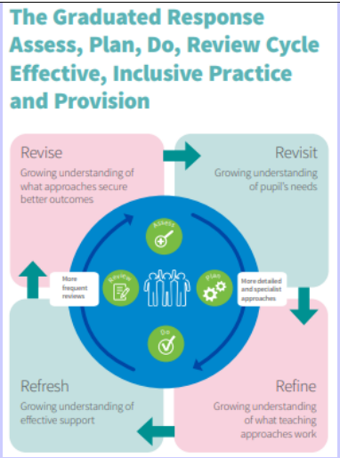
Where the broad approach to SEN Support has been agreed, the teacher (and the SENDCO when deemed necessary) should agree, in consultation with the child and the parents/carers:
• The outcomes they are seeking for the child
• The support strategies to be put in place
• The expected impact on progress, development, behaviour
• Date for review
Plans should:
• Take into account the views of the child
• Any baseline/termly assessments
• Include SMART outcomes: Specific, Measurable, Achievable, Realistic, Time bound
• Select the support strategies to meet the outcomes identified
• Base interventions and support on reliable evidence of effectiveness
• Be delivered by practitioners with relevant skills and knowledge
• Identify and address any related staff development needs

Do
The child’s teacher:
• Remains responsible for working with the child on a daily basis
• Implements the agreed support strategies or programmes
The SENCo can support the key person in:
• Assessing the child’s response to action taken
• Problem solving
• Advising on effective implementation

Review
On the agreed date, and at least termly, the teacher (and SENCO if deemed appropriate)
working with the child’s parents, and taking into account the child’s views, should:
• Review the effectiveness of the support
• Review the impact of the support on the child’s progress by RAGGING the targets/outcomes Red, Amber or Green according to success
• Evaluate the impact and quality of support
In the light of child’s progress, they agree:
• Any changes to the outcomes
• Any changes to the support and
• Next step
The levels of support and provision offered by our school

- Listening to and responding to children and young people

Whole school approaches  The universal offer to all children and YP. | Additional, targeted support and provision | Specialist, individualised support and provision
- We are a small school with smaller than average classes enabling us to provide opportunities for children to speak and be heard.  - Classes work on PSHE, British Values are linked to our weekly worship theme and projects chosen by the children.  - Children have opportunities to lead worship sessions through weekly Open the Book assemblies.  - Children are encouraged to share their views through pupil, group and class conferencing, questionnaires and school council meetings. | - Children with SEND are included in all aspects of conferencing opportunities and consultation. They are supported where necessary to develop their voice. Each child is encouraged to consider who their trusted adults are (those staff with whom they feel they have built a trusting relationship and prefer to speak with.)  - Allocated adults check-in with specific vulnerable children. | - Children’s views are taken into account when planning and reviewing individual support.  - Children’s views are sought and contribute to SEND reviews and TAC meetings.

- Partnership with parents and carers

Whole school approaches  The universal offer to all children and YP | Additional, targeted support and provision | Specialist, individualised support and provision
- The school works in partnership with parents to ensure the best possible educational experience for their children.  - Clear systems exist for parents to talk to, or get messages to, or discuss concerns about their child’s learning with relevant members of staff, by appointment.  - Parents are regularly invited into school for Shared Reading sessions, Reading Cafes, and open afternoons. Children’s progress is discussed within termly parental consultation meetings. | - Parents are offered training, support and information if available linked to their child's individual needs. EHH referrals may be made to enable parents to access Family Support or Parenting Workshops.  - Contacts and websites are also provided as well as practical ideas and support. Information on activities and opportunities for families are forwarded. | - Parents are consulted before and during SEND assessments and programmes of support. They are invited to participate in a range of reviews and meetings and their input is an integral part of TAC meetings and SEND reviews.  - Termly conversations take place to discuss progress and set goals.

- The curriculum

Whole school approaches.  The universal offer to all children and YP | Additional, targeted support and provision | Specialist, individualised support and provision
- All students, regardless of their ability or needs, have full access to the curriculum.  - Topic ‘question-based’ learning and a focus on creativity, enquiry and investigation appeal to and stimulate the children’s interests.  - Parents receive information about the curriculum which is displayed on the school website. These include guidance to aid parents to support their child’s learning at home.  - Topic webs/homework grids are shared with parents. | - Focussed teaching is used to target individual needs within each class and group lesson.  - Precision teaching techniques are used daily.  - Fresh Start sessions are offered to Year 5 and 6 children.  - Targeted KS1 children receive phonics support.  - Ipads have been provided for all children and are used to reinforce learning in key areas.  - The curriculum is also adapted for individuals or small groups as required. | - Some children require a higher level of support and might need an adapted personalised curriculum.  - Individual Education Plans and Education Health Care Plans detail specific curriculum provision made to meet children’s individual needs and are regularly reviewed and updated.

- Teaching and learning

Whole school approaches  The universal offer to all children and YP | Additional, targeted support and provision | Specialist, individualised support and provision
- A range of teaching styles and adaptive learning techniques are used to ensure involvement and progress for all pupils.  - Children have a clear knowledge of expectations regarding their learning and know how to progress.  - Effective questioning is used to gauge the attainment and progress of children, who in turn, respond to teacher’s feedback and marking by editing and improving their work.  - Manipulatives, visual timetables, learning walls are used to support pupil’s access to learning wherever possible. | - Specific support and provision are targeted for children with SEND.  - Teachers and assistants work with small groups or individuals to ensure understanding, foster independence and keep pupils focused.  - Small group interventions target literacy and numeracy, speech and language, co-ordination and motor control, self-esteem and social skills.  - Independence is supported through the use of technology or dedicated computer programs.  - Special examination arrangements are put in place for tests for some children for example the use of a scribe, extra time or modified papers. | - Precision Teaching develops targeted skills and programmes of intensive support are provided for those who would be unable to follow the main curriculum with their peers.  - One to one support is put in place for those with specific learning difficulties.  - The school and families are supported by the Cornwall Council Inclusion Team and outside agencies such as the Speech and Language Service, the Cognition and Learning Service and the County Autism Team.

- Self-help skills and independence

Whole school approaches  The universal offer to all children and YP | Additional, targeted support and provision | Specialist, individualised support and provision
- Independence is encouraged from an early age.  - All children are supported and encouraged to be responsible and thoughtful learners.  - Strategies for independence are taught and reinforced to support children to become more resilient.  - Resources are stored and easily accessible to all. | - Some children have personalised equipment and resources which help them to cope without adult intervention, for example- coloured overlays, fidget toys, ear defenders or wobble cushions. | - Teaching assistants working one to one with pupils with complex and additional needs are trained to withdraw where possible to encourage the children to do as much as possible for themselves.  - Children may be supported with specific medical needs, toileting or life skills.  - Personalised timetables, ‘now and next’ boards, social stories also facilitate children’s independence.

- Health, wellbeing and emotional support

Whole school approaches  The universal offer to all children and YP | Additional, targeted support and provision | Specialist, individualised support and provision
- PSHE is taught throughout the school as well as having a strong Christian and moral viewpoint they are entirely inclusive.  - Each class uses age-appropriate activities to promote the school’s positive ethos.  - Daily worship is a time to carry the thread through to the whole school and staff follow a plan of topics to ensure continuity. It is also a time to celebrate achievement and reflect on feelings and emotions.  - Our school values: Hope, Trust, Friendship, Forgiveness, Creativity and Kindness are shown with our ‘purple tickets’ which are given to pupils who demonstrate one of these core values.  - A healthy lifestyle is embedded in the curriculum and Dojo points are given for healthiness. A healthy tuck shop is offered each day, as well as universal free school fruit and milk for EYFS and KS1 and 4-year-olds.  - Links with the Penryn partnership provide opportunities for children to participate in sporting leagues and tournaments in a variety of competitive sports. We regularly employ Beach or Forest School approaches in teaching and learning across the school.  - All staff are trained in Safeguarding and Child Protection procedures and receive refresher training annually. The Designated and Deputy Safeguarding Leads oversee the and ensure the wellbeing of all children.  - Specialists from outside agencies can be accessed by the school to support children with issues such as bereavement. | - Emotional wellbeing needs and issues are able to be identified within whole class profiling and addressed using a range of supportive strategies.  - Some groups of pupils receive targeted support with issues such as self-esteem, anger management or social skills. Wellbeing is discussed at Pupil Progress Meetings and interventions are put in place as needed. | - A nurturing approach is used with individuals who are experiencing significant emotional difficulties.  - Pastoral support is offered on a 1:1 basis for children experiencing significant emotional difficulties.  - Staff are trained to recognise when external support is needed; such as Educational Psychologists, CAMHS (Child and Adolescent Mental Health Service), School Nurse or Family Support Workers.  - Individual Care Plans and Intimate Care Plans are also created and put into place to manage specific needs.

- Social Interaction opportunities

Whole school approaches  The universal offer to all children and YP | Additional, targeted support and provision | Specialist, individualised support and provision
- There are regular opportunities for children to interact socially in our small school where we work closely with other classes. Topics are linked which enables trips and visitors to be shared experiences.  - Shared reading time is a regular event between the oldest and youngest children in the school.  - Residential opportunities are available for children from Year 5 onwards.  - All have access to after school clubs, trips and social extra-curricular activities. | - Social skills groups target specific children who require support. | - Social story and modelling help some children to develop social understanding.  - Picture communication systems such as ‘PECS’ are sued to help some children to communicate.

- The physical environment (accessibility, safety and positive learning environment).

Whole school approaches  The universal offer to all children and YP | Additional, targeted support and provision | Specialist, individualised support and provision
- Our school is a small, Victorian building with additional modifications over the years. It has a step to the entrance, otherwise, all areas are accessible by all on one level. We have an allocated disabled use toilet.  - All classes have first aid kits and all staff are trained, with some in greater depth, in first aid response.  - Policies about behaviour and risk assessments make the school as safe an environment as possible. We have two playgrounds, one of which has a safety surface for less injuries. Our smaller playground for our younger children also means less collisions with older children and balls etc. They have a play train to enjoy.  - Children know that bullying is not permitted and are confident that staff will support any issues that arise.  - Online safety is discussed during ICT lessons and each class displays our ‘Bee Rules’ and the ‘SMART Rules’ for safer Internet usage. | - A whole school Accessibility Audit is carried out annually. | - Every attempt is made to support children with additional needs having full access to learning and other opportunities. Reasonable adjustments are made in terms of adult support, physical spaces and resources.  - Personalised Emergency Evacuation Plans are drawn up for children when appropriate.  - Specialist seating or sloping desks are sourced and made available according to need

- Transition from year to year and setting to setting

Whole school approaches  The universal offer to all children and YP | Additional, targeted support and provision | Specialist, individualised support and provision
- A transition programme takes place towards the end of the summer term, to enable pupils to familiarise themselves with their new teachers and peers.  - Transition visits to school take place during June and July.  - Pre-schools and home visits are offered prior to the children starting in September.  - Secondary transition sessions happen towards the end of the summer term.  - Sports leagues take place weekly and are based at Penryn College so that pupils can familiarise themselves with their feeder school. | - Small groups or individuals are identified to receive enhanced opportunities for transition sessions. | - Children on the record of need are discussed with both teachers and SENDCo.  - Any children moving to an ARB are taken to visit by the SENDCo and/or TA several times to ease transitional worries. They are also given a point of contact. Families may also attend.  - A common framework for passing on information about SEND has been devised within the Penryn Partnership.

- The SEND qualifications of, and SEND training attended by, our staff

To enable all children to have access to the curriculum, information and guidance, physical environment, school and wider community | To enable targeted support and provision | To enable specialist, individualised support and provision
- All teaching and non-teaching staff take part in a wide range of training relevant to the needs of the pupils. EG  - Safeguarding and Child Protection  - First Aid  - Emotional wellbeing and mental health  - Phonological awareness  - Speech and Language support  - Funfit intervention will run when required  - Tendencies of Dyslexia  - SENDCO attends local support SEND network meetings.  - SEND training is identified during Pupil Progress Meetings, SEND review meetings and where a child with a specific needs joins the school. | - Where small groups require specific provision, training will either be led by a member of the SEND team or will be sourced externally. | - Specialised training may be arranged for adults working with pupils with specific or complex additional needs or medical issues.

- Services and organisations that we work with:

Service/organisation | What they do in brief | Contact details
Physical and Medical Needs Service | Assist school in accessing equipment and developing strategies to improve access to all areas of school life. | 01736 226882  Referral through SENCO.
Speech and Language Therapy Team | The Speech and Language Therapy Team, work with children, young people and families in order to help those with difficulties with communication or with eating/drinking/swallowing. | Cornwall Partnership NHS Foundation Trust.  Carew House,  Beacon Technology Park,  Dunmere Road,  Bodmin  PL31 2QN  Email: cpn-tr.enquiries@nhs.net  CFT Support: 01208 834600
Occupational Therapists | Observe and work with children in school to assess their needs in terms of physical development and sensory needs. | Referral through GP, Paediatrician or county OT service after attending the WRAPS level 1 & 2 courses
Physiotherapists | Observe and work with children in school to assess their needs in terms of physical development. | Referral through GP and Paediatrician
Social Care | Advice and guidance on child protection issues.  Children or families can be referred to social care who can offer practical support at home | Referral through Early Help Hub (EHH) 01872 322277
School Nurse and Health Visitor Teams | Support given to children and families with health-related issues. | 01872 324261  hvsnadvice@cornwall.gov.uk
CAMHS Child and Adolescent Mental Health Service | Assess children who have an emotional or mental health need. Liaise with the school and families as to how to best assist these children and families. | Contact the Early Help Hub  01872 322277
Educational Welfare Support | Our assigned Educational Welfare Officer (EWO) can provide help and advice on:  Attendance issues  Bullying  Child Protection  Exclusion | Karen Varker  Karen.Varker@cornwall.gov.uk
Cornwall Autism Spectrum Team | Support children and families in meeting the needs of children with a diagnosis of Autism. | Autism Spectrum Team  0300 1234101  Admin.staustell3@cornwall.gov.uk
Cognition and Learning Services | This service supports schools in ensuring the effective inclusion, achievement and progression of children and young people with cognition and learning needs. The service works with learners with:  - Specific learning difficulties (SpLD- including dyslexia)  - Moderate Learning Difficulties (MLD) | Cognition and Learning Advisors  cognitionandlearning@cornwall.gov.uk
Early Help Hub | Identifies the most appropriate Early Help service for a child or young person by receiving requests from parents and professionals, assessing the need on request and matching it to the right support service. Services include:  - Early Years Inclusion Service  - Health Visiting (over 2 years)  - Parenting Support  - School Nursing | 01872 322277  Email: earlyhelphub@cornwall.gov.uk
Family Support | The Family Information Service (FIS) offers help to families in the form of free and impartial advice, guidance and signposting to a wide range of agencies and services for children and young people aged 0-20 (or 25 if they have additional needs) | Family Information Service  39, Penwinnick Rd,  St Austell  PL25 5DR  TEL: 0800 5878191
SENDiASS | Information, advice and support for any child or young person and their parents/carers and families age 0-25 with a special educational need or disability. | www.cornwallsendiass.org.uk 01736 751921
Penhaligon’s Friends | Bereavement Support for children, young people and families. | Website:  https://penhaligonsfriends.org.uk  TEL: 01209 210624

For contact details and information about other organisations follow the link on the Family Information Service website to Cornwall’s Local Offer: www.cornwallfisdirectory.org.uk

Cornwall’s SEND Local Offer can be found on The Care and Support in Cornwall website: SEND Local Offer

Answers to Frequently Asked Questions

1. How does your school know if children need extra help and what should I do if I think my child may have special educational needs?

Regular assessment and discussions between teachers and the SENCO enable ongoing monitoring of whether a child has a specific, individual special educational need.
If you are concerned about any aspect of your child’s learning, development, emotional or social aspects, please talk to your child’s class teacher in the first instance.
Working collaboratively as a staff team, with parents/carers and the child, ensures the very best outcomes for your child.

2. Who is responsible for the progress and success of my child in school?

The class teacher is responsible for the progress of all the children in their class. They are supported by the SENCO and, if required, the Senior Management of the school. If children on the school’s SEN Register (SEN Record of Need) are at SEN support or have an EHCP (Education Health and Care Plan), there will be termly meetings to discuss their progress and the best way to accelerate their progress and success.

3. How will I know how my child is doing and how will you help me to support my child’s learning?

Regular parent/teacher interviews will inform you about your child’s progress. You are welcome to discuss concerns at any other time either with your child’s class teacher or the SENCO. All children on our school SEN Record of Need will have a longer parent/teacher meeting, instead of the usual parent/teacher interview, once a term to discuss barriers to learning, targets, progress and provision.

4. How will the curriculum be matched to my child’s needs?

The curriculum will be adapted to meet the needs of all learners. This may be by children having different work to do, having a different expected outcome, extra resources or extra adult help in class.

5. What SEND training have the staff at school had or are having?

All staff are given regular opportunities for professional development both in school and on external courses.

6. How will my child be included in activities outside the classroom including school trips?

All children are encouraged and supported so that they can participate in clubs and on school trips. The school will make reasonable, anticipatory adjustments to ensure inclusion. Individual risk assessments are carried out for children with additional needs and the appropriate support is provided. There may be exceptions to participation if a child’s behaviour is a risk to themselves or others.

7. How is the decision made about what type and how much support my child will receive?

Additional and different provision for your child will be assessed and reviewed on a need basis. The school follows the graduated response (https://www.cornwall.gov.uk/media/ionl50iw/supporting-children-and-young-people-with-special-educational-needs-the-graduated-response-in-mainstream-schools.pdf) as outlined in the SEN Code of Practice (2015) where the ‘Assess, Plan, Do, Review’ cycle is employed to ascertain the type of provision required, its duration and outcomes are carefully measured. Your child may have specific and high-level needs, which means they will only achieve good outcomes academically, socially and emotionally with continuous support and specialised, adapted provision. In this case, the decision may be taken in consultation with you and external professionals, to apply for an Education, Health Care Needs Assessment. If this is the case, the SENCO will talk through the process to ensure support and transparency at each stage of the process.

8. What support will there be for my child’s overall wellbeing?

All staff in school work hard to ensure that your child is safe and happy in school. For children who are experiencing emotional difficulties it may be that they can work with our trained support staff. We work with outside agencies to provide family support. The school nurse is also available to work with you and your child around areas such as anxiety, sleep, weight, eating, toileting etc. You will need to refer yourself through the CHATHealth advice line: Parents / carers of children aged 0-5: Text/call 07312 263 423 Parents / carers of children and young people aged 5-19: Text/call 07312 263 499. Alternatively you can also call 01872 324261 for health advice.

9. How do I know that my child is safe in school?

Risk assessments and safety policies are in place to ensure all children are safe within school. Safeguarding your child is everyone’s responsibility and staff are all trained to do this in an effective and rigorous way. Our designated safeguarding lead, DSL, is the Head Teacher. KCSIE (Keeping Children Safe in Education) training is provided to all staff annually.

10. How will school prepare and support me/my child through the transition from key stage to key stage and beyond?

We work with a number of schools in the area in the following ways:
- SENDnet, Cornwall area SENCO network meetings three times per year
- Transition meetings for pre-school pupils entering EYFS (Early Year Foundation Stage)
- Transition meetings for Y6 pupils with their chosen secondary school
- Monitoring and transition for children who are accessing alternative provision
We ensure that the transition from Nursery to EYFS is smooth, as a result of the class teacher visiting each child with additional needs at each individual nursery.
We support the transition from EYFS to Year 1 by a series of class visits and liaisons between the current and new class teacher and all other adults involved with the individual child. This support continues for each yearly transition throughout the school, if required. Parents and carers are involved in this process as part of the SEN Support or EHCP meeting cycles.
The transition from year 6 to secondary school is supported through transition meetings/sessions with the pupil being at the heart of the process. Enhanced transition visits/packages are co-ordinated by the SENCO in consultation with the child, parent/carer and included external professionals where appropriate.

11. How do you listen to the views of children/young people and their parents/carers?

What | Who | When
Informal Discussions, verbally and via Dojo, telephone and email | All staff | Open door policy  Through appointments or  via TEAMS meetings
Parents/teacher interviews | All teaching staff | Twice per year
Dojo System | Teachers | As required
Assess, Plan, Do, Review meetings for SEN Support pupils and those with Education Health & Care Plans | Pupil, parent/carer, Class teacher and SENCO (if relevant) | Once per term
Early Support/TAC/CAF/CIN/CP  meetings | Relevant staff, family and pupil if appropriate | Six monthly or more often if required
SEN Reviews for pupils with EHCPs | Relevant staff, family and pupil if appropriate | Annually or more often if required
Access to external agencies | External agencies are invited into school during the Spring parent-teacher interviews | Spring term
Transition meetings and visits to relevant educational settings: nurseries, Child Development Centre, APAs (Alternative Provision Academy), Secondary Provision and home visits. | Teachers, SENCO, parents/carers and pupils and relevant professionals | Primarily Summer Term, but also as and when needed.

11. How are the school’s resources allocated and matched to children’s special educational needs?

Each child receives support matched to their own individual level of Special Educational Need. This will vary across each day and throughout their time in our school, as the level of support is directly related to their needs and circumstances. Support is allocated in relation to the child’s individual needs and on the advice of the SENCO and external professionals. Support is monitored closely and adapted as and when necessary. Furthermore, those learners with complex needs and an EHCP will also have Medium Term Plans. MTPs will include the EHCP outcomes and will have the class topic work woven throughout.

12. Who can I contact for further information?

We have an open-door policy and you are welcome to talk to any member of staff about your concerns or queries. Please make your first point of call the class teacher. The SENCO is also able to offer support. You can also contact SENDIASS (Special Educational Needs and Disabilities Information, Advice & Support Service) on: 01326 331633 or The Family Information Service on: 0800 587 8191 who also have a wide range of information on supportive organisations and useful contacts.

13. How is your SEN Information Report reviewed?

The school offer/SEN Information Report is a working document, as we are constantly reviewing our support and interventions. This is also reviewed annually by the Governing Body and Senior Management. A summary of the review will be published on the school’s website as an SEN Information Report. All staff and governors are involved in monitoring and evaluating the provision provided and are collectively responsible for the successful implementation of the offer to ensure success and achievement for all pupils.

14. Our complaints procedure:
Anyone wishing to make a complaint with regard to SEN support and provision should in the first instance talk to the Class Teacher, SENCO or the Head Teacher. The SEN Governor is also available to discuss any concerns.

