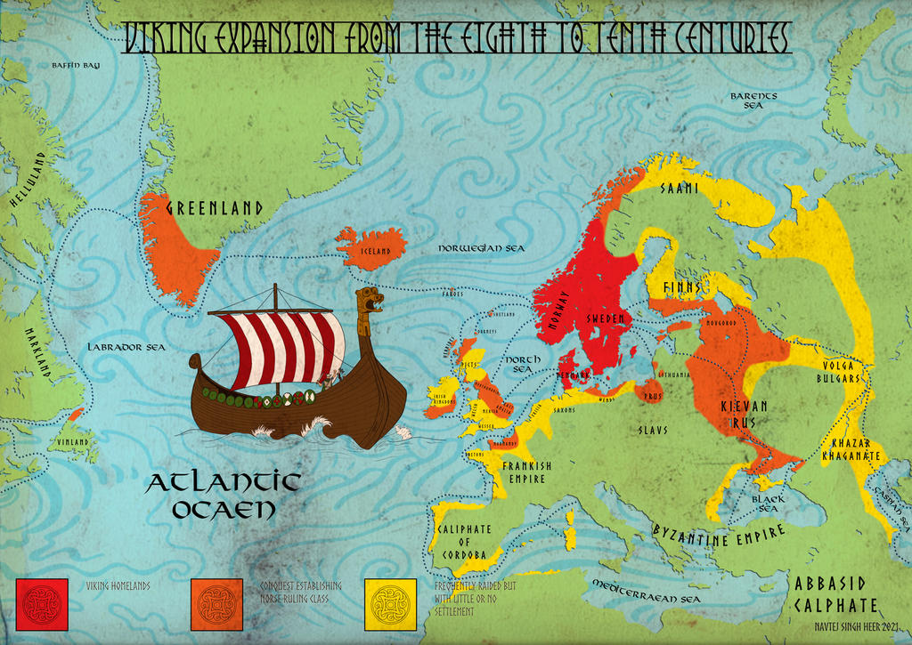
The Vikings came from the modern Scandinavian countries of Denmark, Norway and Sweden. They travelled in boats called longships and first arrived in Britain around AD 787.
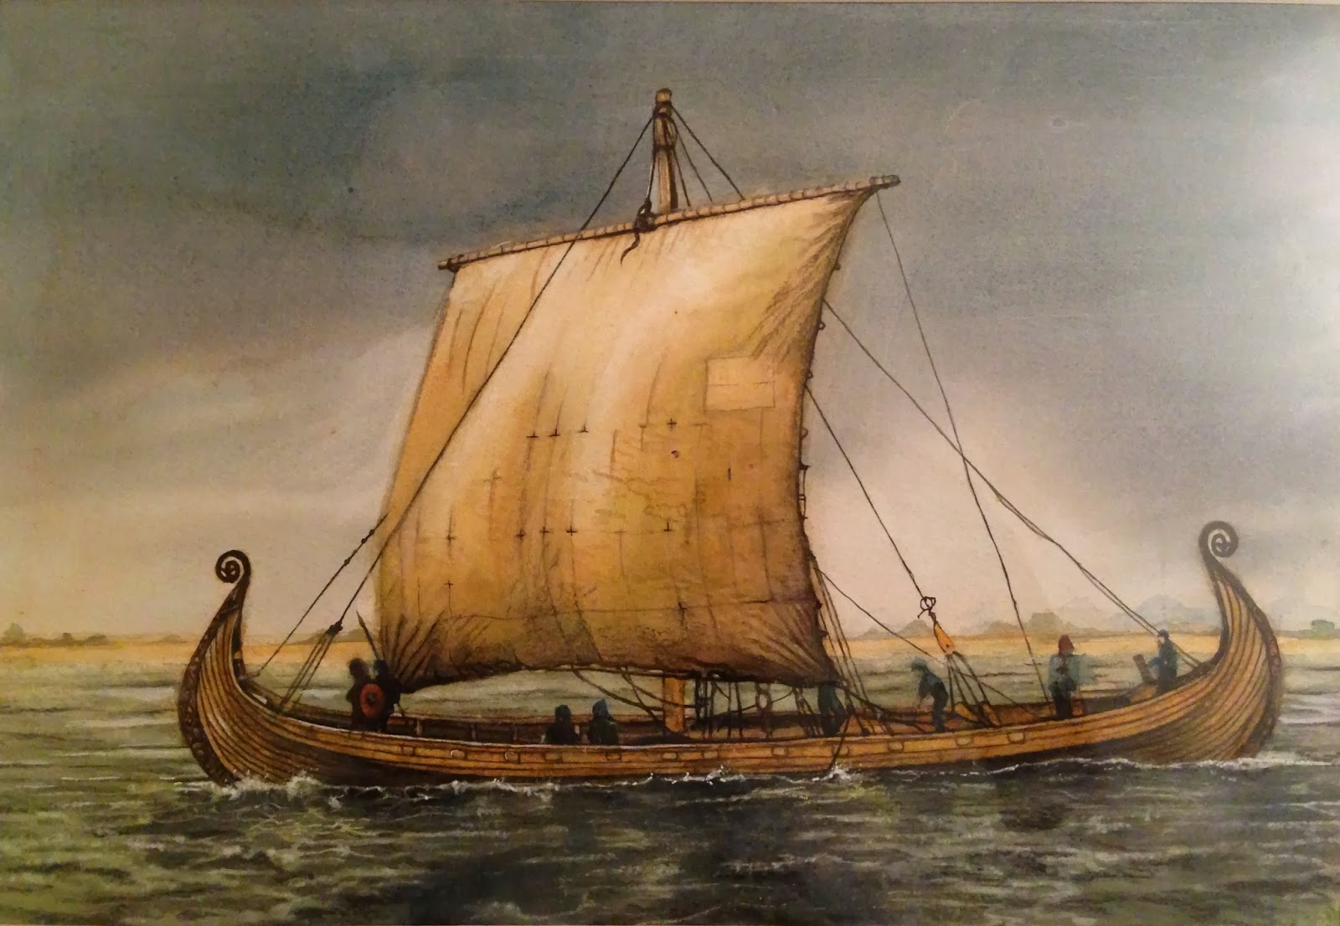
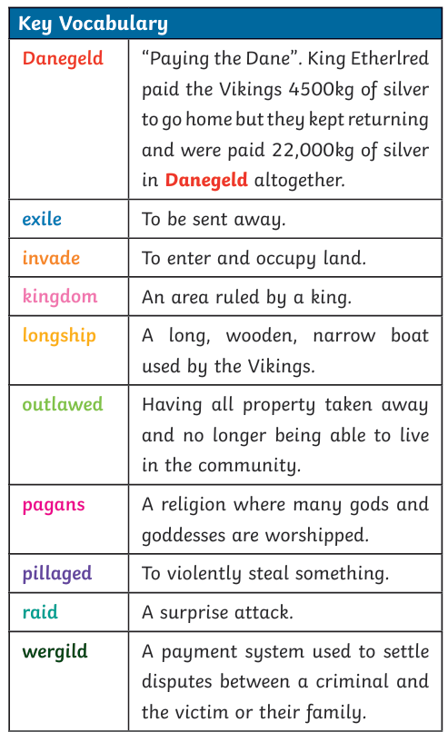
Here is a selection of Viking books including fiction and non-fiction that may be useful for reading around the subject.
Dolphin Homework and Knowledge Organiser: Vikings part 1

Over this half term you need to do just 2 activities:
Complete the mymaths tasks and the grammar task below.
Next half term is only 5 weeks long so there will only be English and Maths homework set. It would really benefit the children if they were to complete their homework before SATs/assessment week (11th – 14th May) however the required dates of Thursday 30th April and Thursday 14th May give them slightly more time than this should they chose to use it.
We will begin our topic on the Vikings this half term but will continue it into June as it is such a short term.

- My Maths - You will find 3 pieces of homework set for you. Sometimes it’s better to do this as the 2nd activity to give us time to cover it in class. You need to do all of the set tasks to count as one homework.

- Literacy
Grammar – Complete the grammar word, definition, example sheet. This links directly to the grammar cards that all the children took home at the beginning of last term. If you have mislaid the cards then there will be a digital copy attached, along with the homework sheet, on class dojo. Please practise the cards at home as they will be very useful for our assessment week. Please keep
the cards safe so they can be returned at the end of the year and passed on to other students.

