Flushing Primary School – ART & DESIGN CURRICULUM MAP |  |  |  | 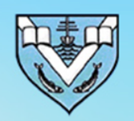
Artistic Concepts | Making skills (including formal elements) Knowledge of artists Evaluating and analysing Generating ideas Using sketchbooks
 | AUTUMN | SPRING | SUMMER
EYFS | Drawing – marvellous marks  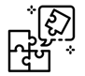 | Painting and mixed media – paint my world | Sculpture & 3D – creation station
Y1/2  YEAR A | Drawing – tell a story  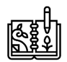 | Painting & mixed media – life in colour | Sculpture & 3D – clay house
Y 1/2  YEAR B | Drawing – make your mark | Craft & design – woven wonders | Painting & mixed media – colour splash
Y3/4  YEAR A | Craft & Design – Ancient Egyptian Scrolls | Sculpture – abstract shape & space | Drawing – Growing artists
Y 3/4  YEAR B | Painting – Prehistoric Painting | Craft & Design – Fabric of Nature | Drawing – power prints
Y5/6  YEAR A | Drawing – I need space | Painting & mixed media – portraits | Sculpture & 3D – making memories
Y5/6  YEAR B | Drawing – make my voice heard | Painting & mixed media – artist study | Craft & design – photo opportunity

