 | Learning Overview |  |  |  |  | Term – Autumn 2026 |  | Class - Dolphins
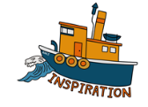 |  | Victorian Dress Up Day  Victorian walk in Falmouth  Black History Month  Bonfire Night  Remembrance  World Kindness Day  Anti – Bullying Week  World Mental Health Day |  | 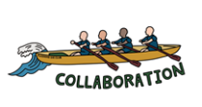  Working | Street Art project in school  Team games at the Bowling Green  Working in groups on science experiments  Reading Cafe with parents  Reading buddies  Harvest Service |  | 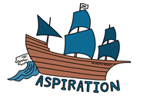 |  | Learn to Skip/ Skipathon  Football and netball league as part of Penryn partnership  Learn about famous scientists and artists
In Science we are learning about: |  |  | In Computing we are learning about: |  |  | In Geography we are learning about: |  | In History we are learning about:
Evolution  Learn how plants and animals have evolved to suit their environments.  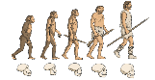  Learn about the work of Charles Darwin.  Living Things  Grouping and classifying plants and animals |  |  | Concept Maps  Children explore how concept maps can be used to organise, develop and present ideas using 2Connect. |  |  | What is life like in the Alps?   |  | 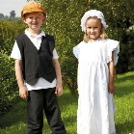  Victorians  Explore the purpose  and creation of a census  Understand what life was like in a Victorian textile factory  Compare census information from contrasting Victorian household
In Art we are learning about: |  |  |  | In Music we are learning about: |  |  | In Design Technology we are learning about:
Drawing  Plan, design and create a piece of Street Art  Skills: One point perspectives, scaling up |  |  |  | We will listen with attention to detail and recall sounds with increasing aural memory. We will perform songs learnt to an audience through our school carol concerts and Source FM carol concert7 |  |  | Structures: Playgrounds  Exploring playground design by creating a model that includes a variety of structures.
In Religious Education we are learning about: |  |  | In Personal, Social & Health Education we are learning about: |  |  | In PE we are learning about: |  | In French we are learning about:
Creation and Science Conflicting or Complimentary?  What does it mean to be a Muslim in Britain today? |  |  |   Being Me in My World  'Who am I and how do I fit?'  Celebrating Difference  Respect for similarity and difference. Anti-bullying and being unique |  |  | Health Related Exercise  Football & netball skills |  | All About Me

