 | Learning Overview |  |  |  |  | Term – Summer 2026 |  | Class - Dolphins
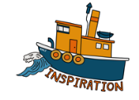 |  | Link geography topic on energy to the war in Iran – discuss how important energy is. Watch Newsround.  Bikeability  Worship at the Beach and Bowling Green  Earth Day  Mental Health Awareness Week  Football World Cup Art Day |  | 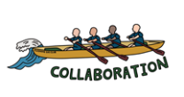  Working | Team games at the Bowling Green  Working in groups on science experiments  Touch Rugby  Residential group activities  Creating invitations for our library opening event.  Sports Day. Colour run  Reading Session with buddies at the beach |  | 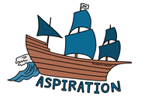 |  | Cricket league as part of Penryn partnership  Midwife visit  Learn about famous scientists and artists  Festival of Science at the University  Healthy Eating – creating salads from garden produce
In Science we are learning about: |  |  | In Computing we are learning about: |  |  | In Geography we are learning about: |  | In History we are learning about:
Properties of Materials  Investigations separating a range of materials  Exploring reversible and irreversible changes  Animals  Grouping animals  Animal gestation periods  The human life cycle  Foetal development  What is puberty?  Looking after our physical and mental health |  |  |   Coding  Program objects to move around a screen.  Create a game using moveable objects on a screen.  Using Scratch |  |  | Where does our energy come from?  We will consider different energy sources, including looking at renewables. |  | Vikings  We will consider whether the Vikings were traders, settlers or something else.  We will look at a variety of sources to create conclusions
In Art we are learning about: |  |  |  | In Music we are learning about: |  |  | In Design Technology we are learning about:
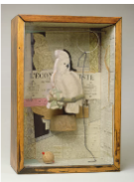  Sculpture & 3D  Plan, design and create a 3D art work in a box representing personal memories. |  |  |  | We will listen with attention to detail and recall sounds with increasing aural memory. We will perform songs learnt to an audience through our school end of term production |  |  | Food & Nutrition – Developing a Recipe  Exploring where our food comes from  Nutrition  Design, plan and create a salad.  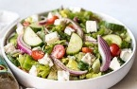  Hopefully using some ingredients from our garden!
In Religious Education we are learning about: |  |  | In Personal, Social & Health Education we are learning about: |  |  | In PE we are learning about: |  | In French we are learning about:
Children will understand what the kingdom of God is and what kind of King Christians believe Jesus was.  We will consider what matters most to humanists and Christians? |  |  |   Relationships  Healthy Relationships and looking after my mental health  Changing Me  Express how I feel about changes, including those during puberty  Pregnancy and birth  The importance of having respect for other people  The importance of looking after myself physically and emotionally  Love and attraction  Challenging negative body-talk  Preparing myself emotionally for the changes next year |  |  | Fielding and striking  We will be looking at the skills of bowling fielding and batting and breaking down elements of each.  Athletics  We will consider techniques for throwing a discus, shott and javelin.  Tactics and teamwork for replay races |  | Greetings  Personal details  Where do I live?  My Family

