PE Funding

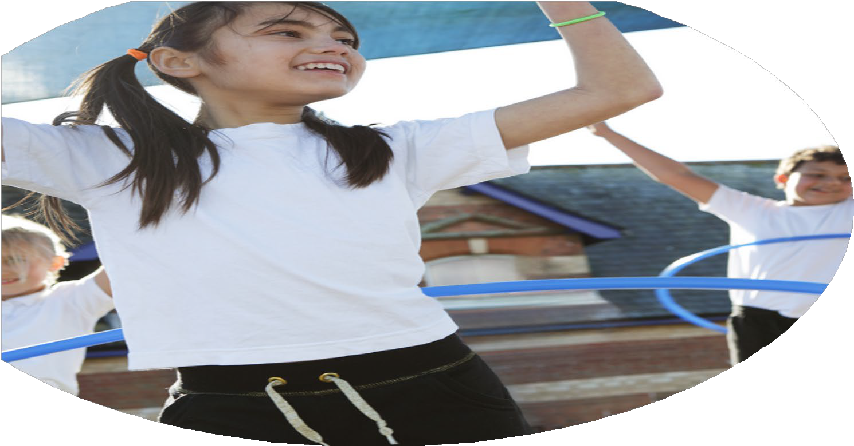

Evaluation Form

**Commissioned by**

**Created by**

Images courtesy of Youth Sport Trust

**PE Funding Evaluation Form**

 It is intended that this template should be used as preparation for the completion of the statutory digital reporting tool being introduced this academic year. You can upload data (including swimming) from this template onto this platform once it becomes accessible.

 Before you decide how you are going to use the funding for this academic year you should reflect and evaluate the impact of your use of the funding in 2023/24.

 All spending of the funding must conform with the terms outlined in the Conditions of Grant document.  The template is a working document that you can amend/update during the year.

 Based on your evaluation of last year’s funding you should decide what you intend to do this academic year, how you will do it, and what impact you expect it to have.

It is important that the funding is used effectively and based on your school’s needs.

 You must use the funding to make additional and sustainable improvements to the PE and sport in your school.  You must develop and add to the PESSPA activities that your school already offers.

*Summative digital reporting from June 2025 will continue to include swimming and water safety information therefore funding can be used to provide top-up lessons where necessary to ensure pupils meet national curriculum swimming requirements.*

**We recommend that you start by reflecting on the impact of current provision and reviewing your previous spend**

|  |  |  |  |
| --- | --- | --- | --- |
| What went well? | How do you know? | What didn’t go well? | How do you know? |
| Use of transport  Penryn Partnership offer  Active Maths  Playground Equipment  Go Active – after school provision | It went well because the school could participate in school fixtures, every class in the school.  New sports introduced Cricket League, working alongside colleagues sharing good practice.  Targeted invention, small groups, to increase confidence and ability on the ABC (Agility, Balance and Coordination.)  Helping children to be more active and engage in sporting activities in break and lunchtimes.  Very popular club that kept children active and engage, unfortunately due to Go Active staffing they were unable to continue this offer. | Adults’ leaders to further develop children’s use of sporting equipment and keeping children engaged.  Real PE- good but needs enhancing. | Not all equipment was used for the purpose it was used for.  Limited resources for dance, gym and PE assessment. |

|  |  |
| --- | --- |
| What are your plans for 2024/25? | How are you going to action and achieve these plans? |
| Intent | Implementation |
| Complete PE – training to be undertaken in February 2025 £183.00  Active Maths – continue as in previous year. £450.00  Funding transport for inter school activities to continue. £1846.00  Equipment – child accessible equipment, (storage.) Playground and PE equipment. £4,600  Extend the competition offer to include 3 x 3 Basketball, and girls football.  Continue with the leagues and swimming gala, sailing, dance club, cross country and multi skills. £560 - supply  Sports Academy – Penryn teacher to identify children by visiting the school ½ termly sessions to enhance skills. £3,000  Staffing- to utilize the offsite provision of PE additional member of staff will be required.  PE – t shirts (waiting until new Logo has been designed)  Penryn Gymnastics – Reception, year 1 £295.00 Transport + £80.00 hire of gym.  Play leader training – to be implemented by Feb – Half term.  Gold training programme – March 25 roll out to year 5/6 and across the school in future.  Bikeability for the 25/26 year.  Embrace dance Fitness = £525 + £560 + £245 (staff)  Sailing Club – Spend £250.00  DTGS – Spend250.00 equipment checks  Village club – use of and resources linked to the Village Club for PE and active sessions £3,000  Maintaining the Bowling Green grass and brushes £1,149 | Bought in Complete PE, training will be given in the staff meeting by the PE Coordinator. |

|  |  |
| --- | --- |
| What impact/intended impact/sustainability are you  expecting? | How will you know? What **evidence** do you have or  expect to have? |
|  |  |

|  |  |
| --- | --- |
| What **impact/sustainability** have you seen? | What **evidence** do you have? |
|  |  |